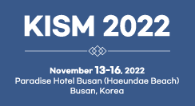 |  |  | KISM2022(한국반도체디스플레이기술학회 학술대회)  Reservation form (2022.11.13-16) |  |  |  | 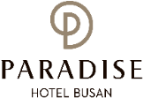
*Check In Date: 2022.11. |  |  |  | *Check Out Date: 2022.11. |  |  | 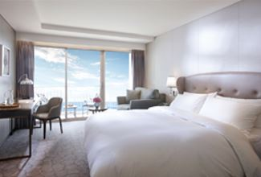  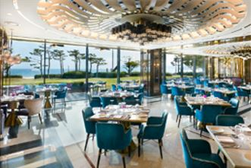  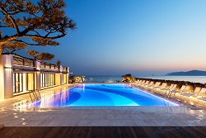
*No. of Persons:
*Name:
*Telephone: |  |  |  | *E-mail:
CREDIT CARD FOR GUARANTEED
*Credit Card Type: ☐Etc. ☐Visa ☐Masters ☐Amex(4Digit-number : )
*Credit Card Number:
*Expiry Date: |  |  |  | *Holder’s Name:
SPECIAL RATE (Unit: Korean Won)
Deluxe Room Type |  |  |  | Mon – Thursday | Friday | Saturday |  | Sunday
1 | Main Bldg.  (본관) | City View |  | ☐ 205,700 (Double)  ☐ 205,700 (Twin) | Surcharge  (인상요금)  +72,600 | Surcharge  (인상요금)  +181,500 |  | Surcharge  (인상요금)  +36,300
2 | Annex Bldg.  (신관) | City View |  | ☐ 229,900 (Double)  ☐ 229,900 (Twin)
3 | Annex Bldg.  (신관) | Ocean View |  | ☐ 254,100 (Double)
4 | Main Bldg.  (본관) | Ocean Terrace View |  | ☐ 290,400 (Double)  ☐ 290,400 (Twin)
5 | Annex Bldg.  (신관) | Ocean Terrace View |  | ☐ 314,600 (Double)  ☐ 314,600 (Twin)
Others. (1) Breakfast Buffet: 42,000/Person. (3) Extra Bed: 72,600/Night
* The rates above are non-commissionable, and they are Inclusive of 10% Service Charge and 11% Government Tax.
* The rates above are NOT included Breakfast.
* Check-in time is 3p.m. Check out time is 11:00 a.m. (If you pass the check-out time, the following rates will apply)
(Until 3pm: 50% of the room rate, After 3pm: 100% of the room rate)
* Free access: Ocean pool(Swimming pool), Fitness Club, Business Center, Kids Villages, Basement Parking Lot, Internet(wifi)
* The spa facilities (Ocean pool, fitness club, Sauna, Cimer) are closed on the fourth Wednesday of every month.
CANCELLATION POLICY
* If you do not cancel on time, the hotel has the right to claim all room charge, which would be deducted from your guaranteed credit card. Cancellation or No-Show after the room reservation is being charged as below.
- From 7days to 5days prior to Arrival date(~18:00): 30% of the Room charge
- From 4days to 3days prior to Arrival date(~18:00): 50% of the Room charge
- From 2days or less prior to Arrival date(Incl. No-Show): 100% of the Room chrarge
Please send your reservation form to: res@paradisehotel.co.kr (Tel no. +82.51.749.2111-3)

